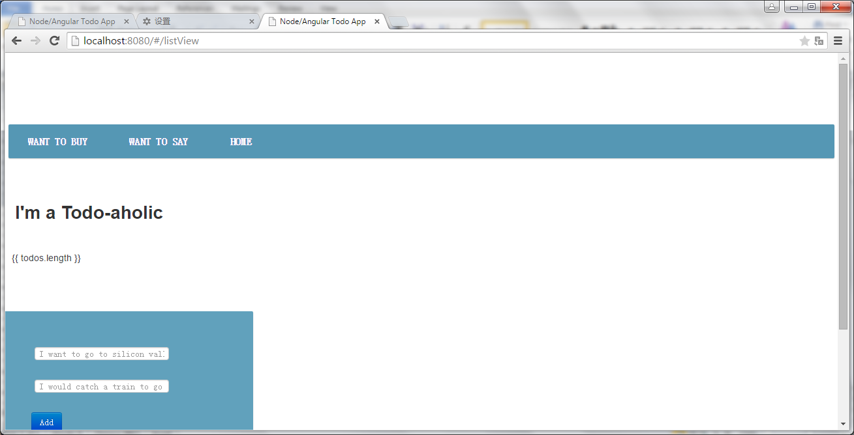

Wrong: angular.module('todoController', [])

// inject the Todo service factory into our controller

.controller('mainController', ['$scope','$http','Todos','$routeParam', function($scope, $http, Todos,$routeParam) {

$scope.formData = {};

$scope.loading = true;

// for listDetailView

$scope.routeId=$routeParam.itemId;

Right:

angular.module('todoController', [])

// inject the Todo service factory into our controller

.controller('mainController', ['$scope','$http','Todos','$routeParams', function($scope, $http, Todos,$routeParams) {

$scope.formData = {};

$scope.loading = true;

// for listDetailView

$scope.routeId=$routeParams.itemId;